Letter : (A-Z|a-z)

Special_Character : !|@|#|$|%|^|&|*|(|)|_|-|=|+|[|]|{|}|:|;|”|’|?|>|<|,|.|/

1. Number : (0-9)*(.0-9+)?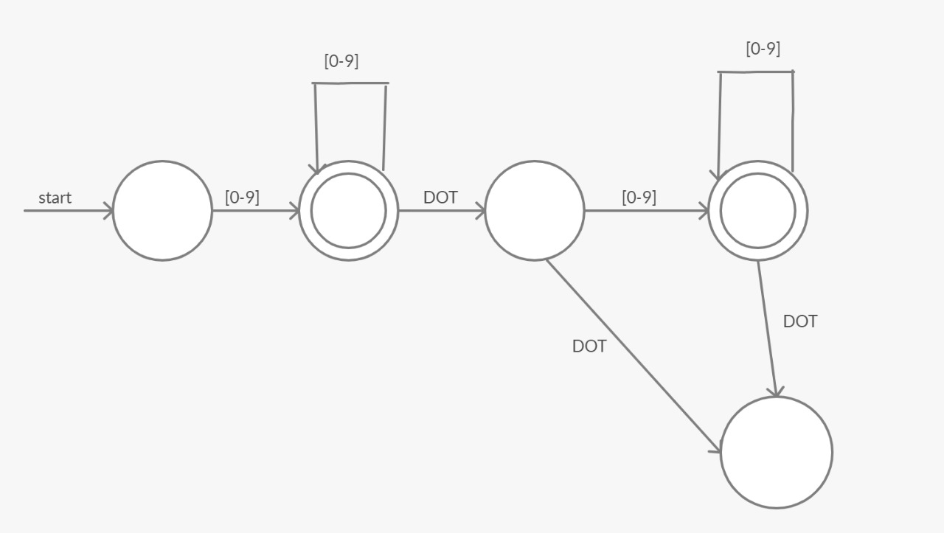
2. String : “(Number| Letter)*”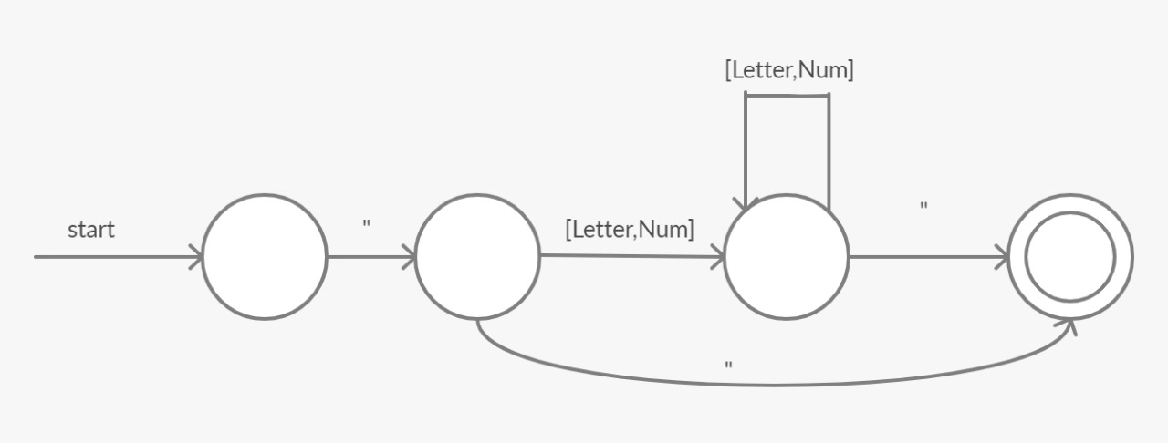
3. Reserved_Keyword : int | float | string | read | write | repeat | until | if | elseif | else | then | return | endl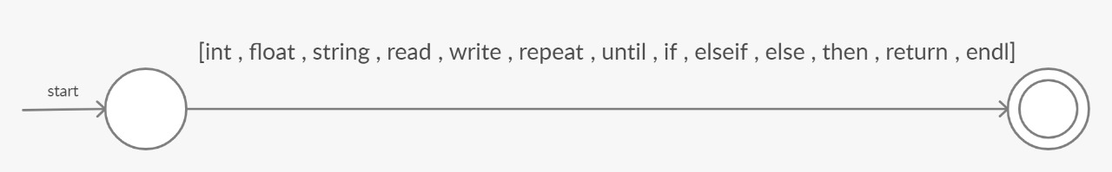
4. Comment : (/*) (Number| Letter | Special_Character)* (*/)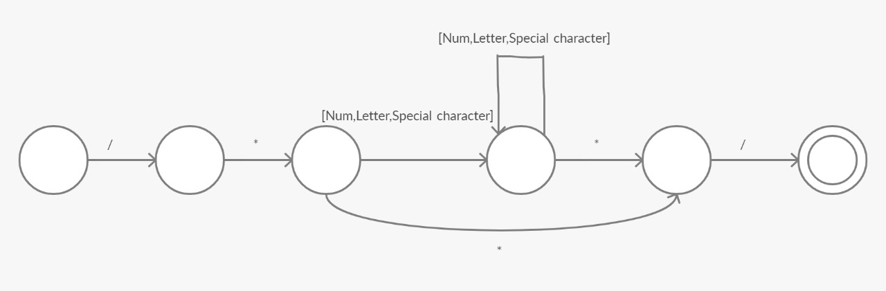
5. Identifiers : Letter (Letter | Number )* 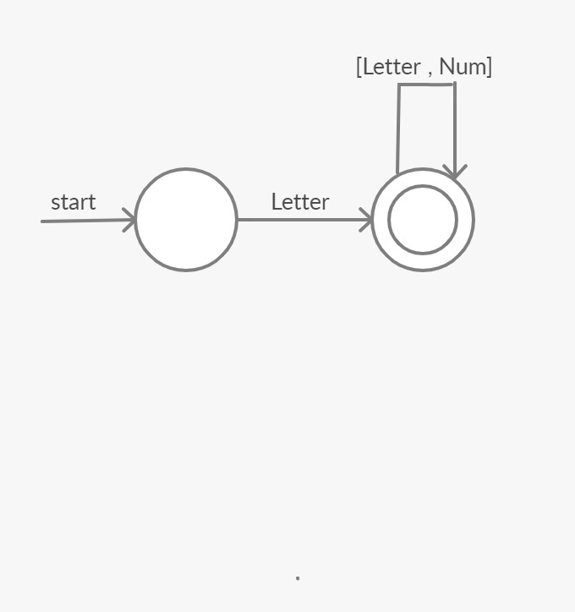
6. Function_Call : Identifiers (() (Identifiers (,Identifier?) )* ())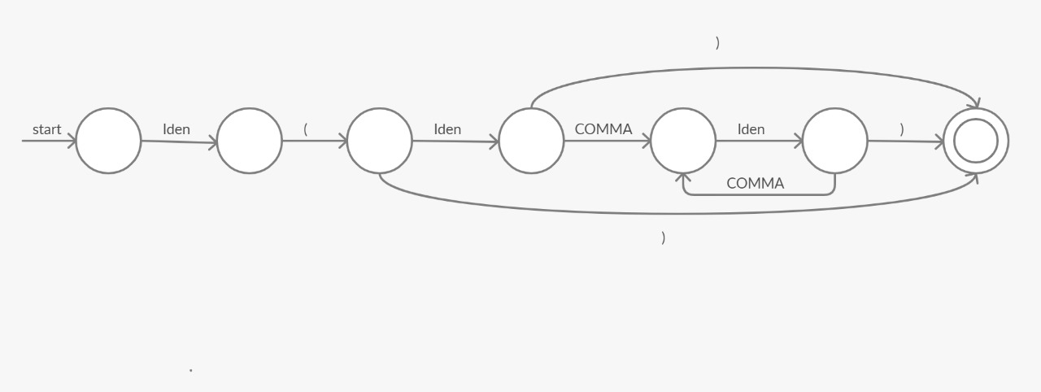
7. Term : Number|Identifiers|Function_Call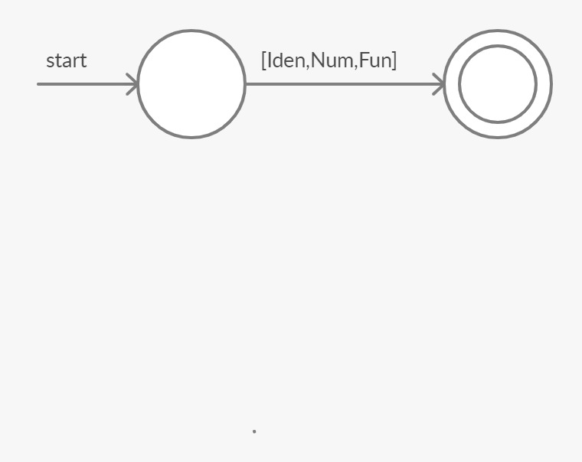
8. Arithmatic_Operator : +|-|*|/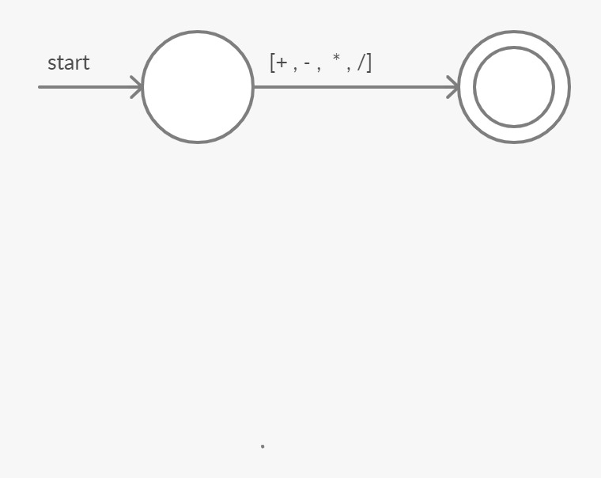
9. Equations : (Term|( ) ( Arithmatic_Operator Term )+ ())?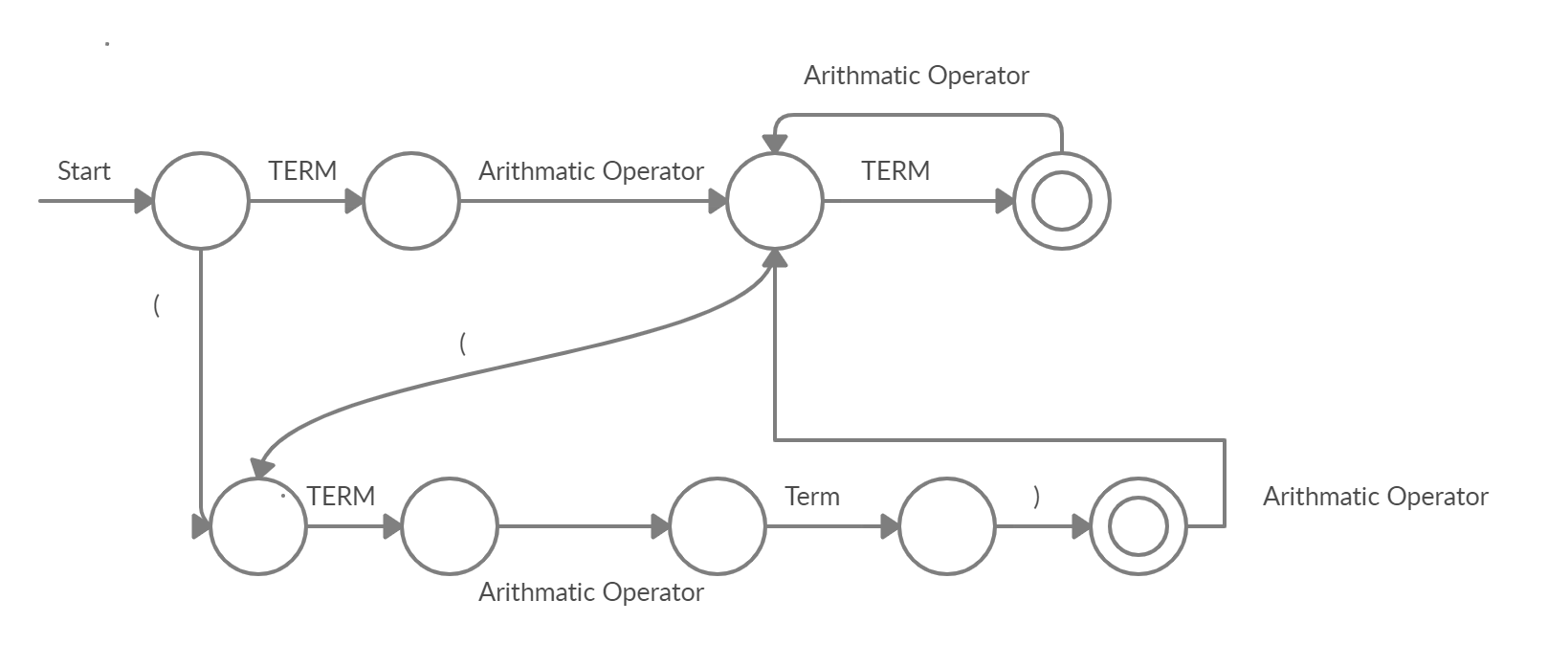
10. Expression : (String | Term| Equation)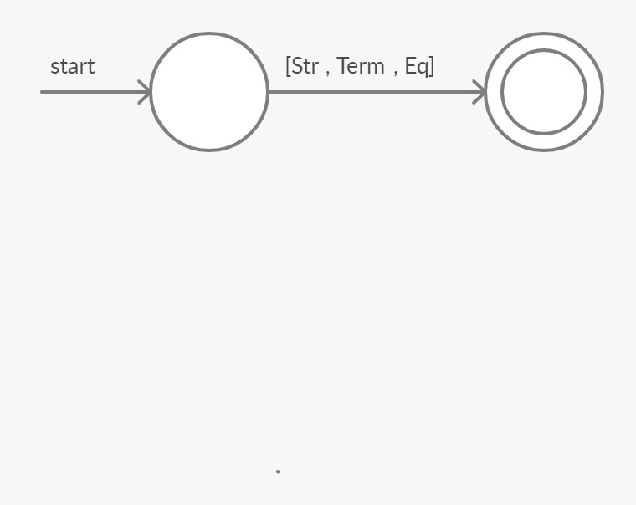
11. Assignment_Statement : Identifiers (:=) Expression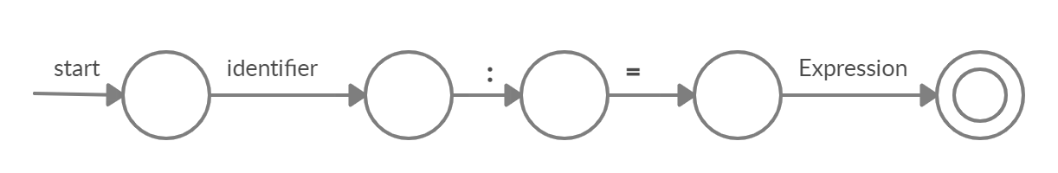
12. Data_Type : int | float |string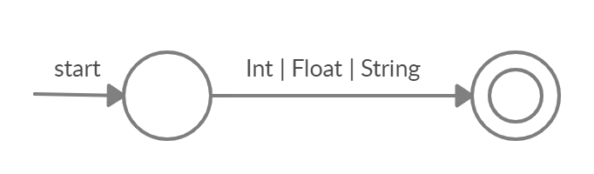
13. Declaration_statement : Data_Type (Identifiers (Assignment_Statement?) (,?))+ ;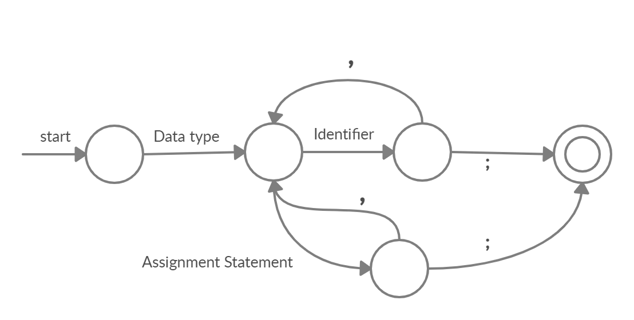
14. Write_Statement : Write (Expression | endl) ;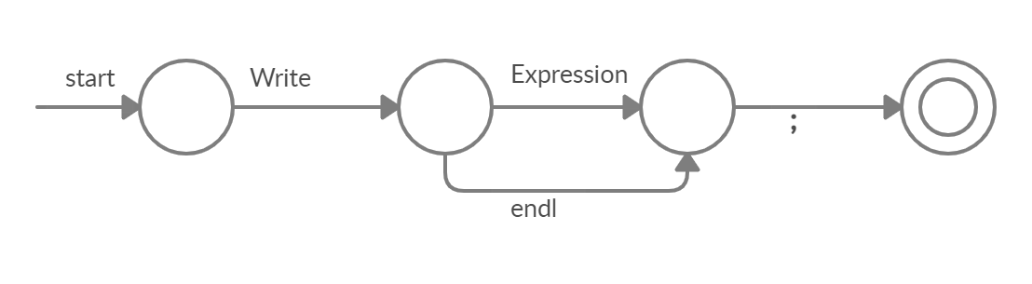
15. Read_Statement : Read (Identifiers) ;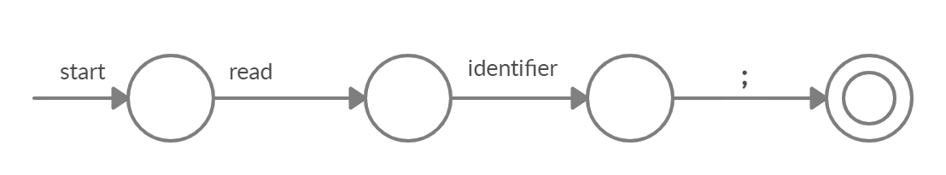
16. Return_Statement : Return (Expression) ;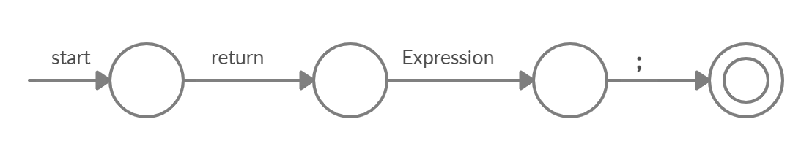
17. Condition_Operator : <|>|=|<>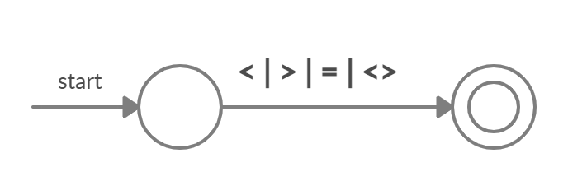
18. Condition : Identifiers Condition_Operator Term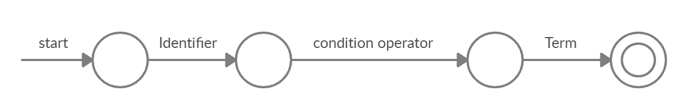
19. Boolean_Operator : (&&) (||)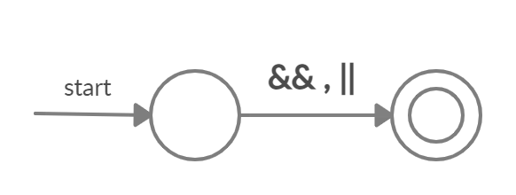
20. Condition_Statement : Condition (Boolean_Operator Condition)* 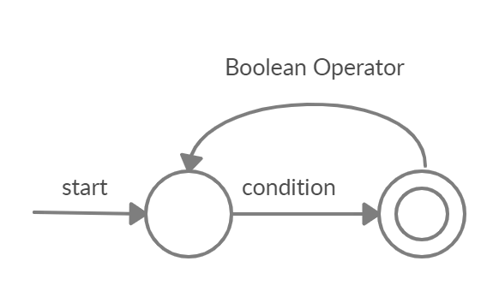
21. If_Statement : if (Condition_statement) then (Declaration_statement | Assignment_Statement | Write_Statement | Read_Statement) (Else_if_statement | Else_statement|end)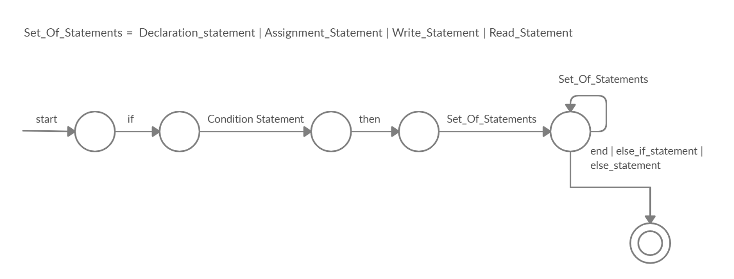
22. Else_If_Statement : elseif (Condition_statement) then (Declaration_statement | Assignment_Statement | Write_Statement | Read_Statement) (Else_if_statement | Else_statement|end)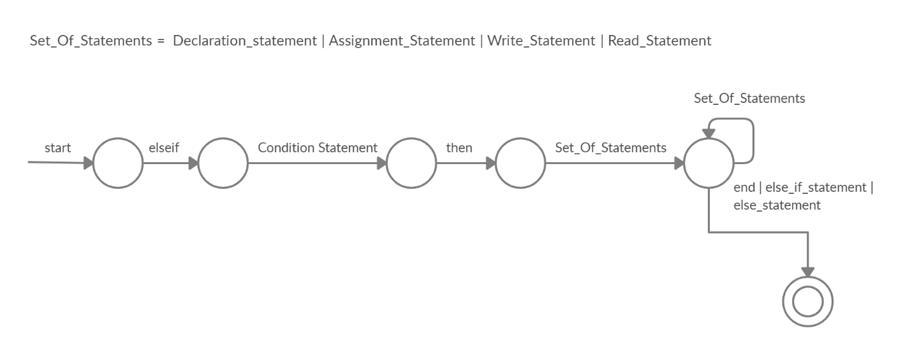
23. Else_Statement : else (Declaration_statement | Assignment_Statement | Write_Statement | Read_Statement) end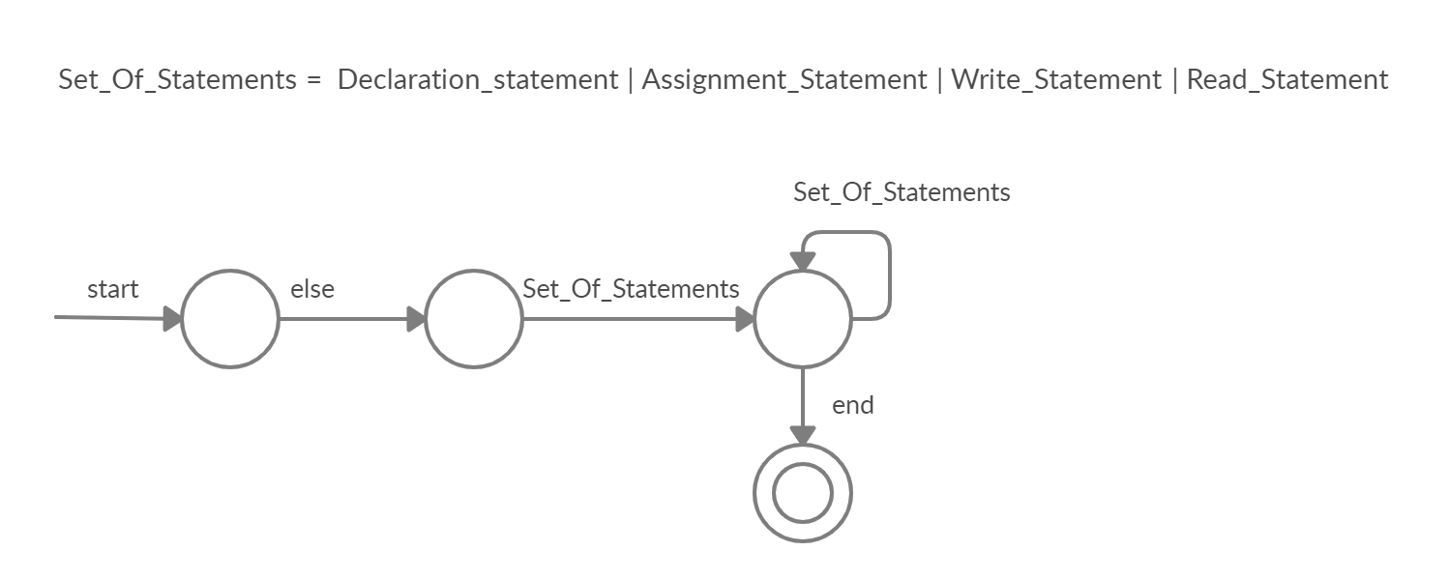
24. Repeat_Statement : repeat (Declaration_statement | Assignment_Statement | Write_Statement | Read_Statement | Return_Statement) Until (Condition_Statement)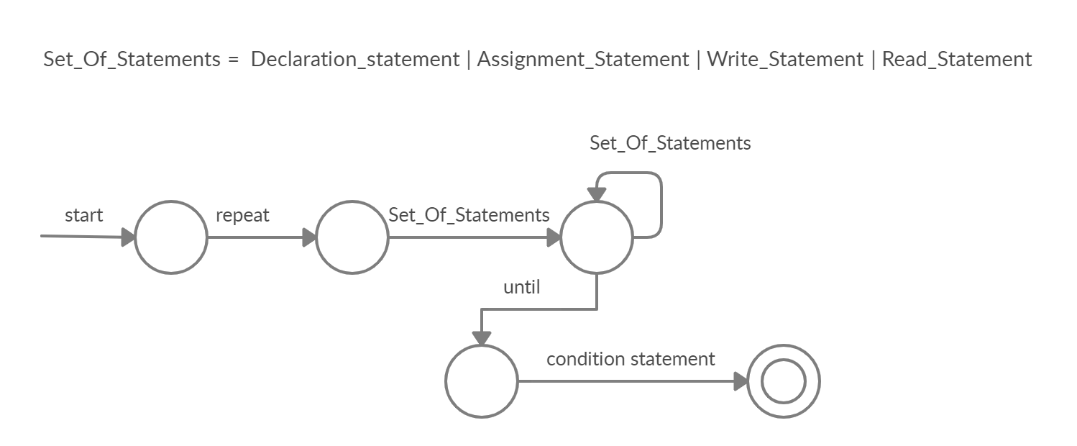
25. Function_name : Letter (Letter | Number )*
26. Parameter : Data_Type Identifiers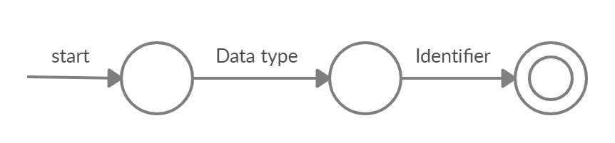
27. Function_Declaration : Data_Type Function_name ( **(** ) (Parameter (,Parameter?))* ( **)** ) 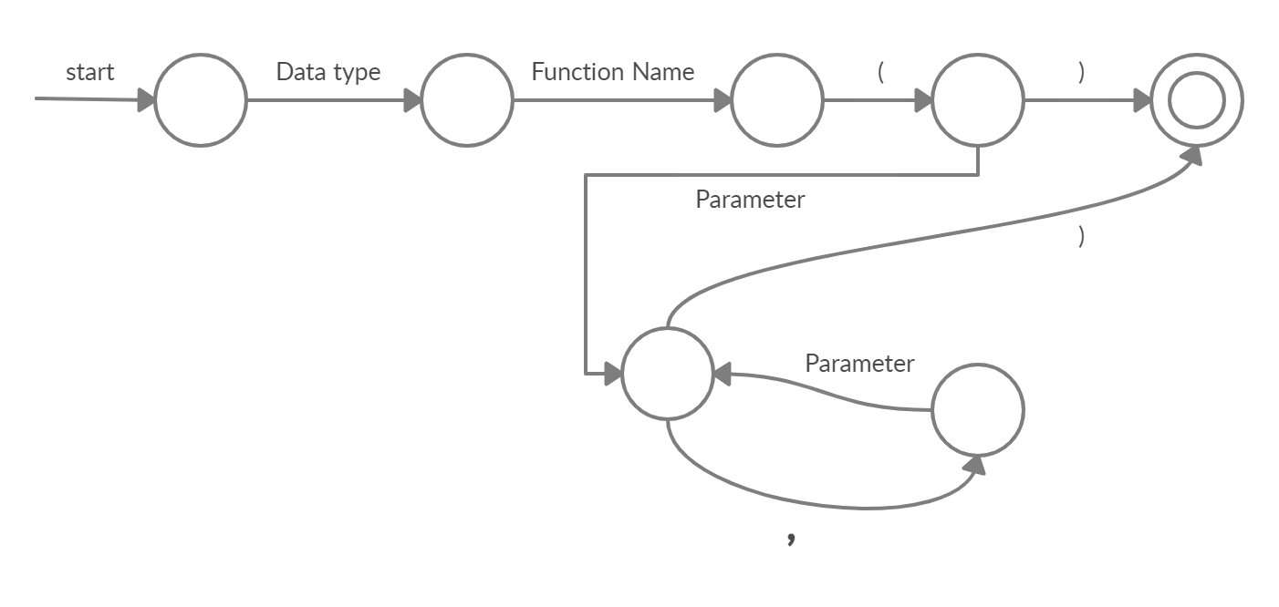
28. Function_Body : ({) (Declaration_statement | Assignment_Statement | Write_Statement | Read_Statement ) Return_Statement (})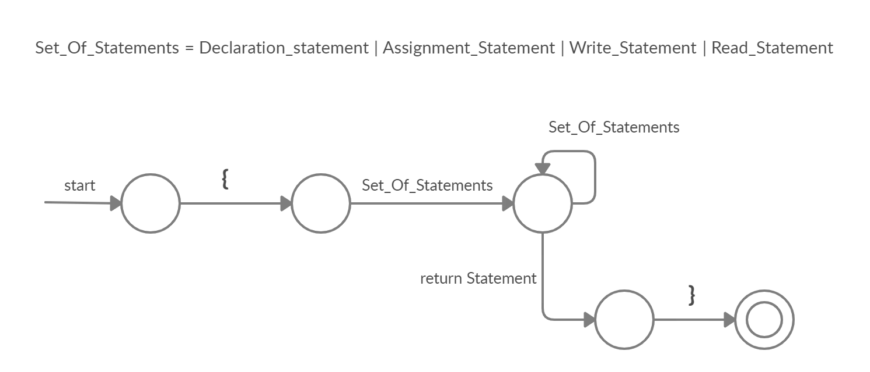
29. Function_Statement : Function_Declaration Function_Body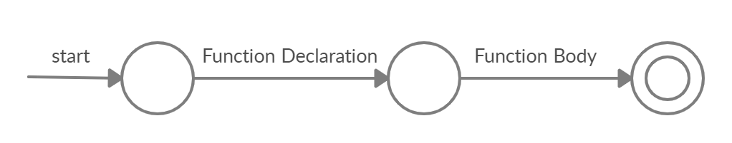
30. Main_Function : Data_Type (Main) ( () ) Function_Body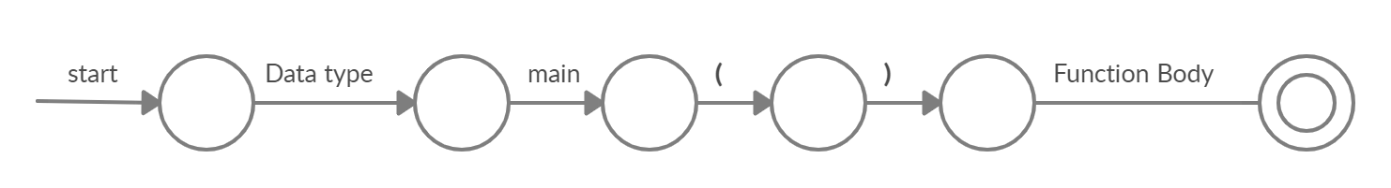
31. Program : Function_Statement* Main_Function